Universidad Europea de Madrid
Fluid Mechanics II
Homework 3
Computational Fluid Dynamics
Due on October 3, 2016
Problem 1
Use an explicit method to determine the temperature distribution, for 2 seconds and 3 seconds, for a steel rod with length of 100cm. The initial temperature of the rod is 300K. One end is at 440K and the other end is at 273K. Remember to set up the criteria of stability (λ).
Problem 2
Numerically solve the heat transfer problem for aluminum panel (Square panel 1m x 1m). The top side is maintained at 500Celsius and bottom side is maintained at 100Celsius the other two sides are maintained at 0Celsius. Plot the temperature distribution on the plate.
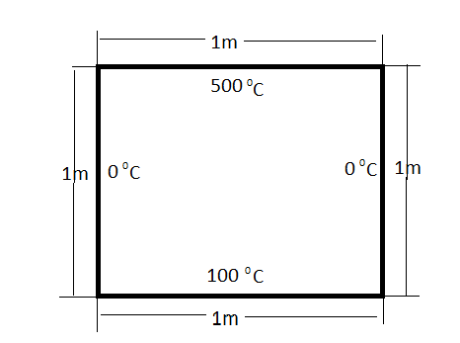
Problem 3
Numerically solve the Couette flow problem for velocity distribution. The upper plate is fixed plate and the lower plate is moving at 60m/s. The plates are separated 20cm. Plot in the same graph the analytical and numerical solution. Make your conclusions.
Problem 4
Consider the viscous flow of air over a flat plate. At a given station in the flow direction, the variation of the flow velocity, u, in the direction perpendicular to the plate (the y direction) is given by the expression

$$U=1582(1-e^{\frac{-y}{L}})$$
Where L= characteristics length 3cm, the units of u meters per seconds. The viscosity coefficient μ is 3.7373X 10⁻⁵ kg/(m-s). Using the above equation to provide the values of u at discrete grid points equally spaced in the y direction, with Δy=0.1cm. Specifically, it is obtained

y, cm | u,m/s
0 | 0
0.1 | 51,86
0.2 | 102,02
0.3 | 150,5

Using discrete values, calculate the shear stress at the wall
- Using a first order difference
- Using the second order difference
($\frac{∂u}{∂y})=(\frac{-3u_{1}+4u_{2}-u_{3}}{2∆y} )$
- Exact value

